Have to create an IAM role In the json file add “ CloudLogGroup” then create a policy.

1.Create cluster

2.Task Definition:

Follow the below steps.

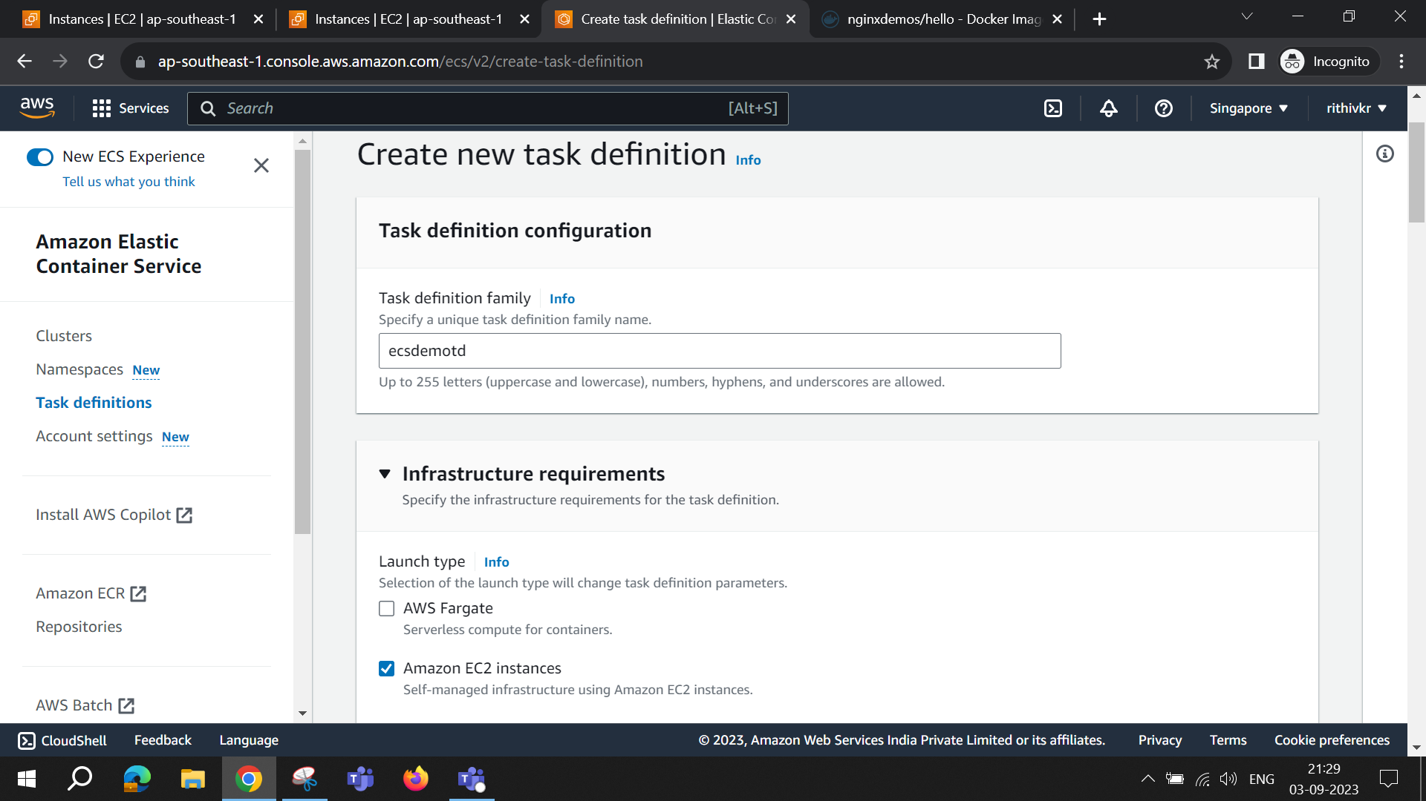

Create Service:

Below screenshot click the networking option and add the created security group

Then Click “create”